TASK | Application of instant gasket sealant to fork truck parts
LOCATION OF USE | Workshop and on Client sites |  | Assessment  No |  | 017
PRODUCT NAME | Hermitite Silicone Sealant & Instant Gasket |  |  |  | 017
DESCRIPTION OF SUBSTANCE | Viscous. silicone rubber. |  |  |  | 017
MANUFACTURER | Hammerite Products Ltd,  Prudhoe,  Northumberland,  NE42 6LP |  |  |  | 017
MANUFACTURERS CONTACT | TEL: 01661-830000 |  |  |  | 017
ASSESSOR | Martin Monaghan CMIOSH |  | Date |  | 23 07 24
TITLE | Health and Safety Consultant |  | Review by |  | 23 07 26
Personnel Performing Task  (Please list below)  Technicians/ Fitters/ Workshop Operatives |  | Time Spent  (Minutes/day)  As and when required, amounting to a few minutes per day | Training Given 
 |  |  | Yes

MSDS Revision Date | Hazard Statement
18-02-03 | Irritating to eyes and skin.

Assessment to be conducted in Association with Hazard Data Sheets, a full current copy of which must be attached to this assessment.

Please denote the hazardous properties of the substances used in the task with a

NEW INTERNATIONAL GLOBALLY HARMONISED HAZARD SYMBOLS
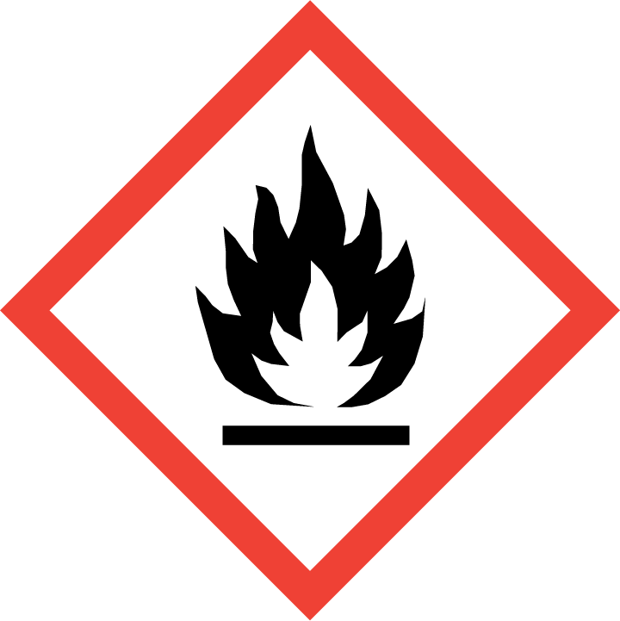 | 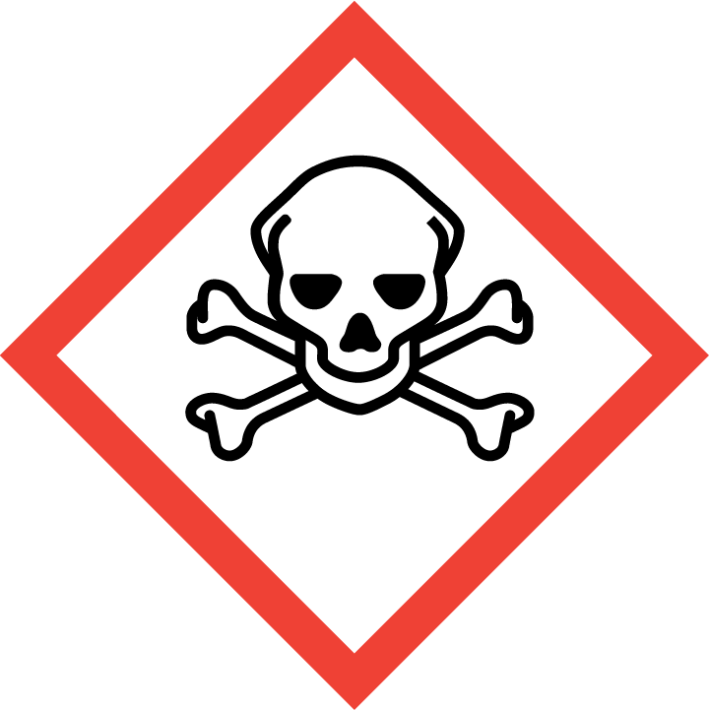 | 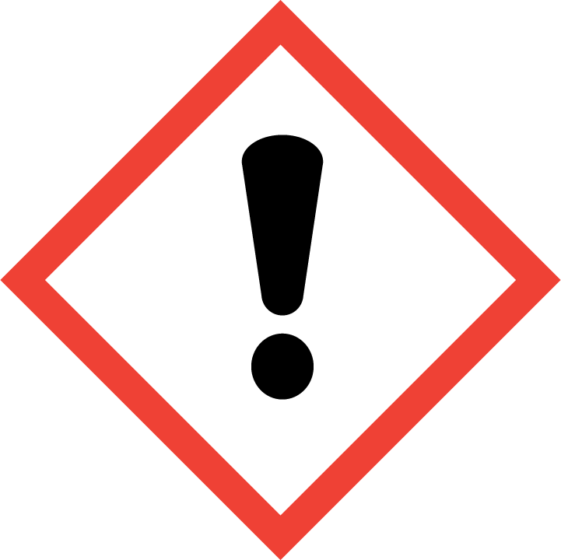 | 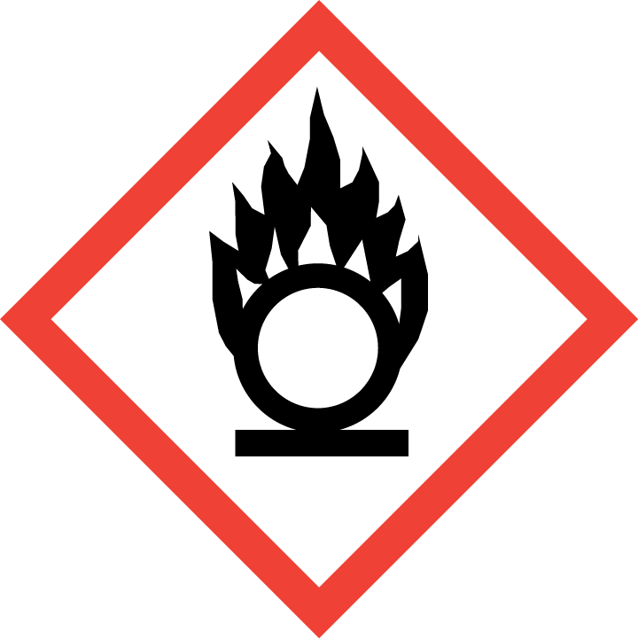 | 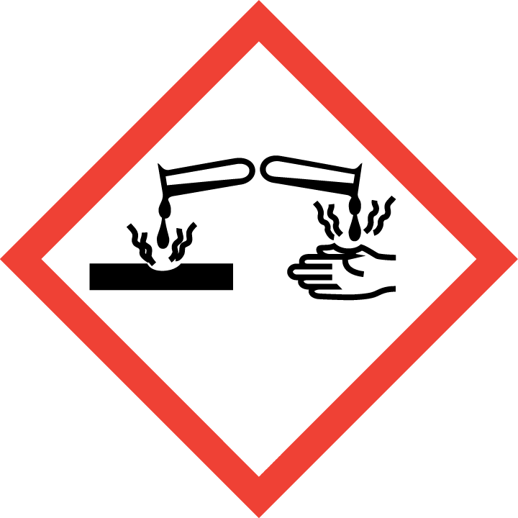 | 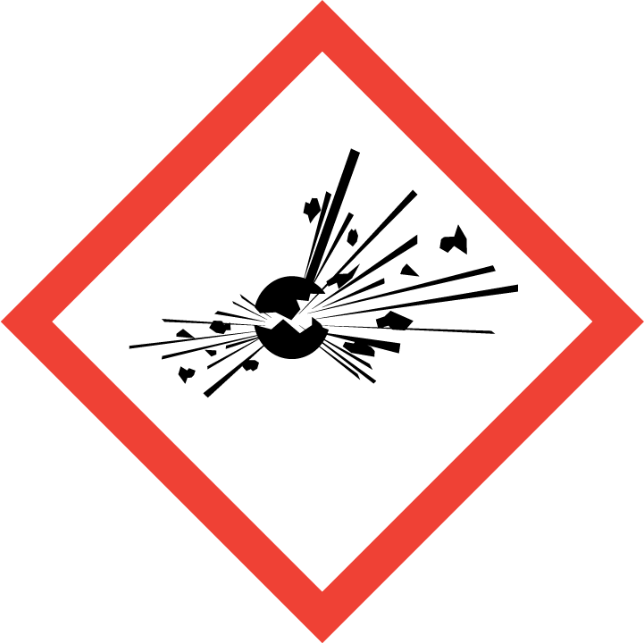 | 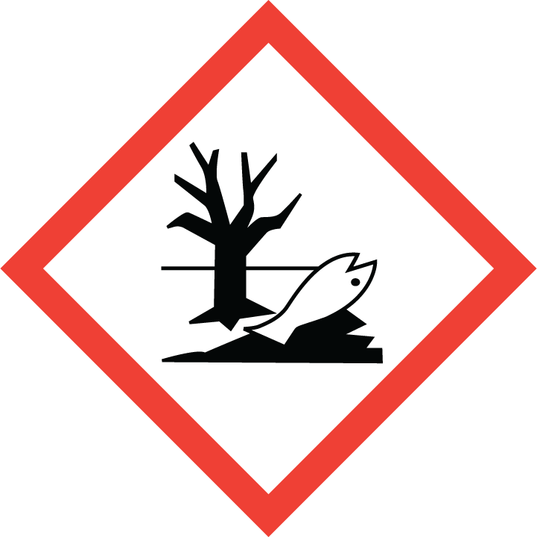 | 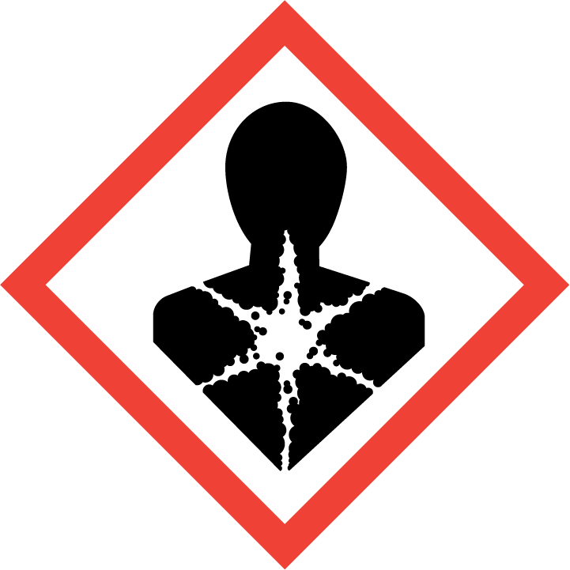
Flammable | Toxic | Harmful | Oxidising | Corrosive | Explosive | Harmful to the environment | Health Hazards i.e. respiratory sensitisation or carcinogenicity

SMOKING, EATING AND DRINKING ARE PROHIBITED IN THE WORK AREAS.
Information, Instruction and Training must be provided to all users. Young Persons, New or Expectant Mothers and other vulnerable groups must not use or be exposed to this product.

WORKPLACE EXPOSURE LIMITS (WEL’s)
No WEL applicable for product.

IMPORTANT!
Refer to Workplace Exposure Levels information provided in the Manufacturers Safety Data and revise control measures if exposure levels likely to be reached.

ROUTE OF EXPOSURE
Skin |  | Eyes |  | Inhalation
Ingestion |  | Cuts/abrasions |  | Systemic

PERSONS AT RISK
User of product |  | Co workers |  | Members of the public

ROUTE OF EXPOSURE |   FIRST AID MEASURES
Eyes | Remove contact lenses. Irrigate copiously with clean, fresh water for at least 10 minutes, holding lids apart. Seek medical advice.
Skin | Remove contaminated clothing, wash skin thoroughly with soap and water, or use a proprietary skin cleanser. Do not use solvents or thinners. Seek medical advice if symptoms persist.
Inhalation | Remove to fresh air, keep patient warm and at rest. If breathing is irregular or stopped administer artificial respiration. Give nothing by mouth. If unconscious place in the recovery position. Seek medical advice.
Ingestion | If accidentally swallowed, DO NOT INDUCE VOMITING. Keep at rest and obtain medical attention.
In all cases of doubt, or if symptoms persist seek medical attention. Never give anything by mouth to an unconscious person. If unconscious, place in recovery position and seek medical advice.

PERSONAL PROTECTIVE EQUIPMENT
 |  | 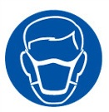 |  | 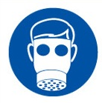 |  | 
YES | YES | YES/NO |  | YES/NO | YES | YES/NO
YES | YES |  |  |  | YES - Chemical Resistant

HANDLING | STORAGE | TRANSPORT | DISPOSAL
Keep away from heat, sparks and open flame. Avoid skin and eye contact. R.T.V. silicone rubber  releases acetic acid vapour while curing. Ensure good ventilation during application and curing. | Store in a cool, dry ventilated place. Keep away from children. Store away from direct heat and  foodstuffs. | The product is not classified as dangerous for carriage. | Dispose of waste and residues in accordance with local authority requirements.

REQUIRED CONTROL MEASURES
- Ensure only minimum amounts are transported and used.
- Ensure approved impermeable gloves are used at all times,
- Ensure overalls are worn and these are suitably laundered.
- Ensure that a suitable tool or rag is used to wipe away any excess product, never your finger.
- Ensure that work is undertaken in well ventilated areas, where significant use is required ensure a suitable vapour/particle respirator is used.
- Ensure that Engineers are equipped with antibacterial hand washes and wipes and that good hygiene practices are enforced.
- Provide engineers with suitable barrier creams.
- Ensure that soiled rags are disposed of appropriately.

FIRE PRECAUTIONS
Water spray, fog or mist. Alcohol resistant foam. Carbon dioxide (CO2). Powder.

ACCIDENTAL RELEASE/SPILLAGE PROCEDURES
PERSONAL PRECAUTIONS
Keep away from sources of ignition - Do Not Smoke. Avoid contact with skin, eyes and clothing.
Do not breath vapours. Observe all safety precautions. Absorb in vermiculite, dry sand or earth and place into containers.
Clean area with detergent. Avoid using solvents.
ENVIRONMENTAL PRECAUTIONS
If the product enters drains or sewers the local water company should be contacted immediately; in
the case of contamination of streams, rivers or lakes, the Environment Agency. Spillages should
be contained and covered with sand or other absorbent material to prevent the flow of liquid into
drains, sewers, basements etc.

MONITORING REQUIREMENTS AND HEALTH SURVEILLANCE
Health surveillance is not in place for workers exposed to this product.

